**Contents**

**1. Functional requirement**

**2. Non-functional requirements**

**3. Application analysis**

**4. Individual contribution**

**5. List of pending work**

**6. Screen Shoot from Github:**

**7. Github link**

**Team E**

**Team members: Cloud**

**Suraj**

**Ciya**

**Progress report**

# Functional requirements progress:

Functional requirements are written with a purpose of mentioning all the functionalities which a software will provide.

## TITLE: User registration

Progress: The prototype design for this registration form and a sample working coding have been done for the user registration. The sample working code is also attached in github repository.

RAT: The user will be able to register in this web application.

## TITLE: User log-in

Progress: After registering themselves the user will be able to log in in this web application, log in credentials are based on their registration. NET MVC provides the in-built log in service such as individual authentication which is also added to github for the group to test upon.

RAT: To allow registered users to sign in into the web application.

## TITLE: View car list

Progress: This page is for displaying list of cars which is uploaded on this web application. The number of cars are to be displayed on this page as per their background details such as company name, model year and type. Design is core aspect for this page and design structure is made by our group. Possible improvement in the design of this page are expected till the end of the project testing.

RAT: To provide user list of cars to select and view the description of their desired car.

## TITLE: Searching a car

Progress: Search operation is one of the core functional requirement for this web application due to the ease of access it gives to the user to find the car of their interest. The best possible attempt has been made to create a SQL query which can give the result as per the search criteria. A sample ajax code has also been worked out to load one drop box menu to another drop box menu. First menu is for selecting the brand of car and another is for the car name.

RAT: To allow user to search a car based on the brand, model year, price and name.

## TITLE: Add to cart

Progress: The user will be led to the add to cart form once he/she has selected the desired car. This page will display the product attributes, price and quantity. However, there will be a button to cancel the item if user is no more interested to buy the selected product.

RAT: To provide add to cart page with product attributes to review order before buying product.

# Non-Functional requirements

1. maintenance

our team will follow four important rules to make sure our application will easily to maintain at future.

1. Easy to analyse: The defect or cause of failure in the software product diagnostic software or the ability to identify the part to be modified.
2. Easy to change: The software product enables the specified changes to be implemented by the ability to implement changes including coding, design and documentation
3. Stability: Software products avoid the ability to cause unexpected results due to software modifications.
4. Easy to test: The software product enables the ability to modify the software to be confirmed.
5. Reliability

We will through the reliability test to view the probability and availability of the software, The main purpose for our application reliability testing have three point.

1. Software needs to confirm if correctly implemented in the operating environment.
2. For software reliability estimate collect accurate data.
3. Through the software reliability test to find all the greater impact on the reliability of the software error
4. Test

We will through TDD (Test-Driven Development) to make sure all the function works smoothly, before we write the code, we use the test function in the visual studio to do some of test for make sure the function development will goes well.

# Application analysis

# Activity Diagram

Activity diagrams shows the different activities involved in the application. It also provides the clear overview of application from one starting point to end point. We use for five active diagrams to presents the workflow of each activities and actions with different choice. These five diagrams are used to explain registered, search, login, member management and item management those five different actions

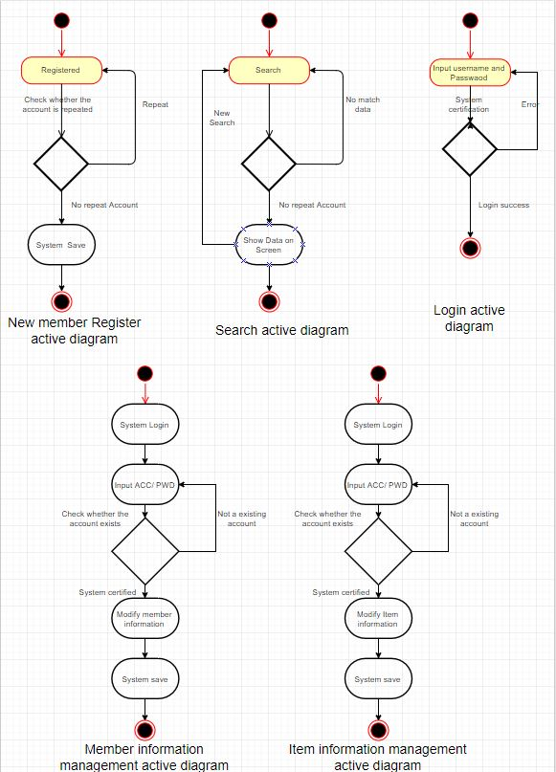

# Use case Diagram

In the process of project development, understanding the needs of users is a very important thing, but it is likely that even the user himself is not very clear what they need, therefore, we can use the use case diagram to assist in defining requirements. The diagram below shows the interaction in each actors and functions, we can see the buyer can interact with sign in, sign up, search, booking and order functions, those functions provider to buyer a car shopping environment to buyer. Admin interact with sign in, sign up and search, but also interact with item management and user management functions for Information management work. Seller also interact with sign in, sign up and item management functions, because in our system planning, the seller need provide the item(car) information to admin, and admin will help seller upload all the item information to application when the admin confirms the all of the relevant information, we hope that through such a mechanism to reduce the problem of deception.

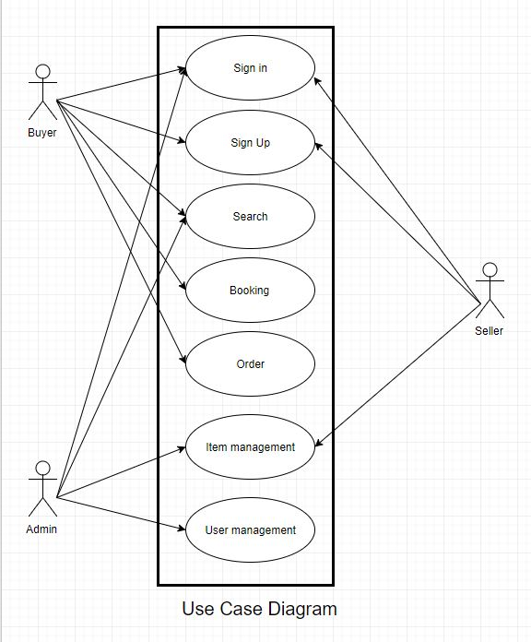

# State transition Diagram

State transition Diagram is a diagram to represent a machine that has a number of states, When the event occurs, the event will drive the machine to change his state. The diagram below show that start pint into the web application, when entering a different machine and through a different event selection will produce a different state.

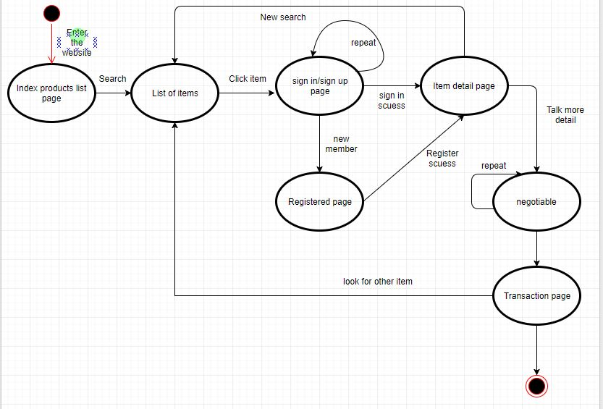

# Individual contribution:

1. Cloud (Team leader):

Database: Although the database diagram and entity model were constantly discussed within group meeting during classes, the finalization were made by cloud as expected from the leader.

Diagrams: The initial version of Activity diagram, flowchart, state transition diagram and use case diagram are drawn as per the requirements and project plan.

2. Ciya (Team member):

Front-end design:

* User registration form is designed as well as login. Where possible textbox, dropdown menu and buttons are designed
* Design prototype is prepared for listing of cars. Used bootstrap and w3cschool css3 attributes for providing simple and attractive design prototype.
* Search div (tag) block have been designed to provide users with search service as the sequence of brand, car name and price.
* Add-to-cart form prototype.
* Car details page structure.

3. Suraj (Tem member):

Back-end coding:

* Database is successfully plugged with front end portion of the web application. Initially, sample scaffolding was used for the data manipulation.
* The registration form and initial registration table is plugged together to enter the registration information in to the registration table of the database. Initially, the individual login authentication were used for the application to work successfully on the first sprint of the application.
* Login credentials are being verified with the user registration data once they verified users are able to log in.
* List of cars and relevant information from the carDetail table are fetched from the database to front end design portion.
* Database is successfully plugged with front end portion of the web application. Initially, sample scaffolding was used for the data manipulation.

Requirement specification:

Functional requirement such as registration, car list view, search and add to cart are written down using appropriate format by Suraj. Non-functional requirements such as reliability, maintenance, and security and user friendliness are written down by Ciya as her designing helped her to decide how much effective non-functional requirements are for this web application.

# List of pending work:

## Technical:

* Search: Ajax code for reloading one dropdown menu based on the selection of another drop down menu.
* Add to cart: The add to cart service functionality remains undone which needs to be worked in ongoing days.
* Design improvement in the car view page: This is the page where list of cars have to be represented attractively to users where comprehensive information of cars must be available in an organized manner that guides users through the buying process and also gives the user friendly experience.
* Multi selection for the car: The business logic for selecting more than one car to buy.
* Categorising car: Organizing the available car based on their type and brand.
* Admin panel: Admin panel supposed to have authority to manage the user except editing the details of user.
* Car management access to admin where admin will be have authority to add and delete the car information and also to deactivate the car status which is not supposed to be displayed to user.

## Documentation:

* Sequential diagram: The diagram which shows list of activities and their sequence will need to be worked upon.
* Performance requirements.
* Functional requirements and non-functional requirements are still to be formatted for the final documentation for this project.
* UML diagram: Class diagram and use case diagram.
* System attributes.
* Still working to comply with IEE standards for the documentation writing.

## Testing:

Even though registration module and car view page are tested, test cases remains are yet unwritten on Upcoming sprints, Add to cart module, multi selection search module, and on admin management access.

## Project delivery:

Once three sprints are done within time limit, the amount of testing will increase and final changes will be analysed and made only if required. The final sprint may be approached if any needed. Once the project documentation and development phase is completed, the application will be provided to our lecturer Nare as per the required time limit.

# Screen Shoot from Github:

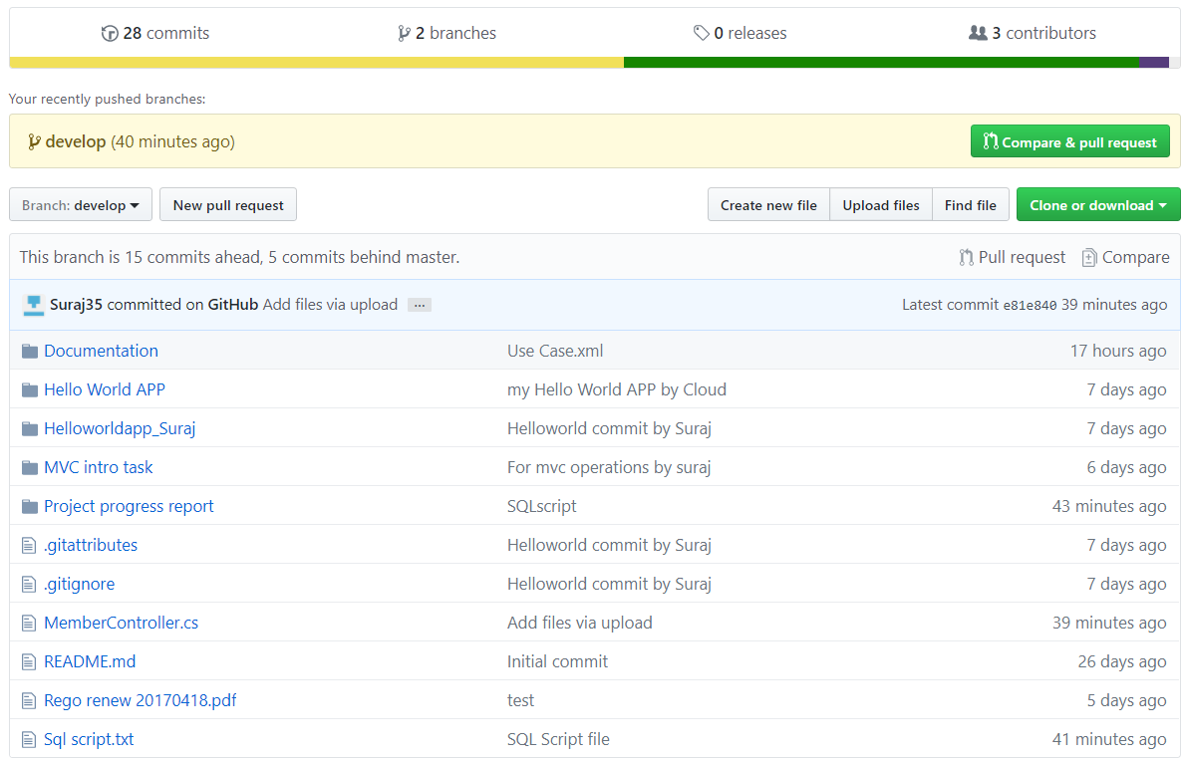

**Github link:**

<https://github.com/CIYA/PRT455-Project/tree/develop>